**Memory Game**

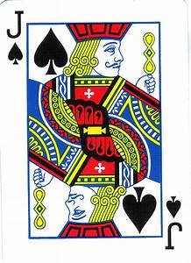

* The user can Click on the cards to turn them over
* Once the user matches two cards, the cards disappear from the interface
* The user starts at level 1 and progresses to level 5
* The user can choose between single player and two player
* The difficulty of each level will also be variable.
* The table below lists the timings and how they change for difficulty
* If the user cannot match all the available cards in the given time the player loses the game

|  |  |  |  |  |
| --- | --- | --- | --- | --- |
|  | **# of pairs** | **Easy (mins)** | **Medium (mins)** | **Hard (mins)** |
| Level 1 | 6 | 20 | 10 | 2 |
| Level 2 | 10 | 30 | 15 | 3 |
| Level 3 | 16 | 40 | 20 | 5 |
| Level 4 | 22 | 50 | 25 | 7 |
| Level 5 | 36 | 60 | 30 | 10 |